MOTION DETECTION WITH ALARM

Sourabh Godara

20CSU344

Sourabh20csu344@ncuindia.edu

# Abstract

# Stealing precious items is one of the world's never-ending challenges. A variety of detection gadgets are already on the market. For example like provide an alarm that can be actuated with a remote control. Regrettably, these gadgets did not have the capability of automatically detecting theft attempts and alerting the owner. Camera-based theft detection will be utilized in this research to detect theft occurrences with the help of image processing. The system will record image frames and, by comparing the two frames, it will be able to detect motion, and an alarm will be triggered promptly with the statement that the administrator wrote in the specified software.

# INTRODUCTION

Stealing is one and the most widespread and oldest criminal practices, and it is becoming more prevalent by the day. Crimes are increasing not only in one region of the world but also globally. People have suffered from anxiety and loss because of the rising occurrence of theft. To combat the global increase in theft a theft deterrent system is needed that is simple to use, doesn't frequently set off false alarms, and doesn't need constant human intervention to arm and disarm. Anti-theft system focusing primarily on the room security system will be designed. This gadget, which will be installed within the room and positioned on the ceiling, will detect motion and be capable of distinguishing between fraudulent and genuine theft by detecting motion and distinguishing between subtle and major changes in the picture. An application or software is used to switch on the output device with the click of a button or by simply pressing a key on the keyboard.

Additionally, the output device must be able to be turned off with a keyboard or a mobile phone click. The camera will be used to detect movements in the shop or any other secure place for this project.

# 

# 

# 

# 

# 

# EASE OF USE

Because the system doesn’t have a complex hardware structure, the user will find it easier to arm and disarm the system as needed. The owner will only need to mount the camera on the ceiling of the room or shop and provide power to it. When the system is activated, it detects motion and The alert will be triggered by the statement that the admin entered into the developed program. Because a program will also be created for the user's simple system interaction, such as START and STOP.

# SYSTEM DESIGNING

We suggest a new strategy to address the issues with the current work, which would help to minimize project costs by removing the needless use of hardware.

**Camera Input**

Anti-theft gadgets will need at least a 5-10V power supply after the Camera module starts working inside the room or store. The entire system will start to work on supplying the device with a constant power source.

**Enter Theft**

The system will begin taking pictures as soon as it is installed and given a sufficient power source. When the store or room is closed, every movement infront of the camera will trigger a theft entry detection and cause the algorithm to go on to the next step.

**Decision Making:-**

The first image that is captured will be used as the reference picture. The warning won't sound if the new current image matches the reference image, however, The system will begin an alarm (text-to-speech) if there is a mismatch between the reference image frame and the current image frame, as specified in the defined algorithm or code.

**Approach**

There are basically two approaches described in this by any one approach you can understand this project:-

**General Frame vs Previous Frame**

General frame means the current frame(frame contains many images taken by camera).

Previous frame means frames just before the general frame(frame contains many images taken by camera).

Comparing the General frame of a live video with the previous frame is a common method for a motion detector. It is notably helpful in video compression for estimating changes and for writing only the changes rather than the entire frame.

The differences between an original grey scaled frame and the previous video grey scaled frame are first distinguished using Difference and Threshold filters. On the set threshold value, a picture with white pixels in the different regions is produced. If the value exceeds a set alert threshold, a motion event may be signaled.

Since noisy images are typically produced by cameras, an erosion filter is then employed to remove errant noisy pixels. A morphological filter called Erosion alters the shape of objects in an image by increasing the limits of dark objects and eroding (reducing) the boundaries of light ones. It is frequently employed to decrease or get rid of tiny, brilliant items.

The interest zones are mostly the only ones being recognized at this point, therefore an actual motion is obtained. The drawbacks of the method had been found in the image below. From frame to frame, there are minute changes if the item is moving fluidly. So, it is a challenge and challenge to get the entire moving thing. When an object moves so slowly that the algorithms produce no results at all, the situation gets worse.

**General Frame vs First Frame**

General frame means the current frame(frame contains many images taken by camera).

First frame means the frame at the beginning(frame contains many images taken by camera).

A different strategy is to make a comparison between the general frame and the first frame of the video sequence. Comparison of these two frames revealed the entire moving object, regardless of how quickly it was traveling.

The first frame of the video series is designated as the background frame at the start. Future frames are constantly compared to this backdrop frame. The most crucial strategy, in this case, is to "move" the background frame on the specified number of levels per frame, for example, in the direction of the present frame. After that, each frame's background frame's pixels have their colors adjusted by one degree.

Building the scene or background frame as a reference to compare with the present frame is one of the most effective motion detection algorithms. Compared to the majority, which is overly complex, some of the strategies mentioned below are straightforward.

**PYTHON**

A high-level interpreted computer language for general computing is called Python. Python has an automatic memory management system in addition to a dynamic type system.. It has a sizable and varied standard library, supports a wide range of computer paradigms, including imperative, functional, procedural, and object-oriented. There are Python interpreters available for many different types of operating systems. Python, the standard Python implementation, and virtually all its forks are open-source programs with a project-based development method.

**LIBRARIES IN PYTHON**

The extensive standard library of Python, which is frequently cited as one of its best characteristics, offers tools appropriate for a variety of applications. For applications that interact with the internet, a number of standard formats and protocols, including MIME and HTTP, are enabled. It has modules for building graphical user interfaces, establishing connections with relational databases, generating pseudorandom numbers, performing decimal arithmetic with arbitrary accuracy, working with regular expressions, and performing unit tests. The majority of modules are not specified, but a few are (for instance, the Web Server Gateway Interface (WSGI) implementation strictly adheres to PEP 333). They are defined by their internal documentation, test programs, and code. (if supplied). Only a small number of the standard library's modules need to be changed or completely rewritten for different implementations, though, as the bulk of it is written in cross-platform Python. User interactions with graphics

* Web frameworks,
* Multimedia,
* Databases,
* Networking
* Test Frameworks,
* Automation,
* Web Scraping,
* Documentation,
* System Management,
* Scientific Computing

Libraries used in this Project: -

**Open cv:-**

A programming function package aimed primarily at real-time computer vision is called OpenCV (It is an Open-source Library for computer-vision and developed by Intel). There are different computer-vision algorithms in the collection. contrasts what is referred to as the OpenCV 2.x API, which is really a C++ API, to the C-based OpenCV 1.x API.

**Pyttsx3:-**

**The text-to-speech conversion tool pyttsx3 is written in Python. Unlike other tools, it can work offline and is Python3 and Python2 compatible. An application uses the pyttsx3.init() factory method to obtain a reference to a pyttsx3. It is a straightforward instrument that speaks text that has been entered. Two voices, one masculine and one female, provided by "sapi5" for Windows are inbuilt in the pyttsx3 module.**

**Threading: -**

Python **threads** are a type of process entity that can have their execution scheduled. A thread is, to put it simply, a computation process that a computer will carry out. It is a series of these instructions inside of a programmed that can run separately from other codes.

**Time: -**

The Python time module allows you to work with time in Python. It allows you to do things like get the current time and stop the programme.

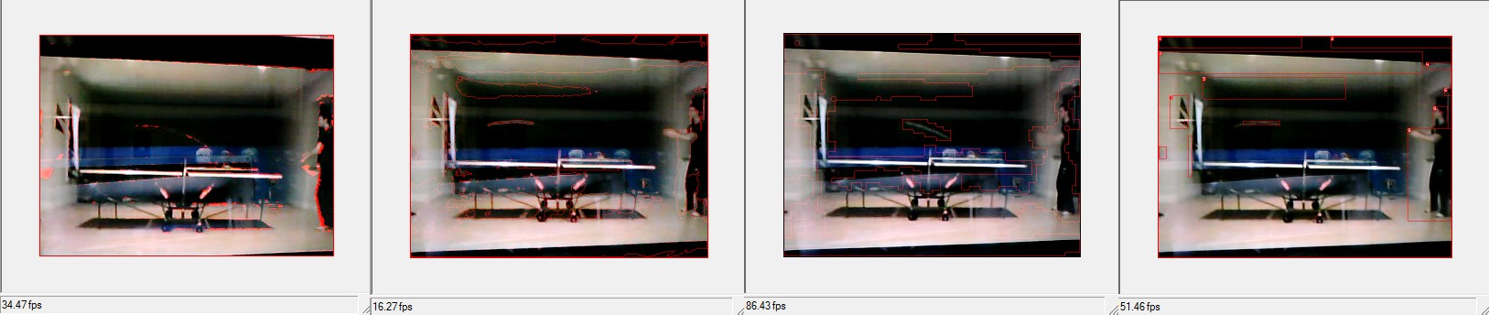

Fig( Testing whether the motion is detected or not)

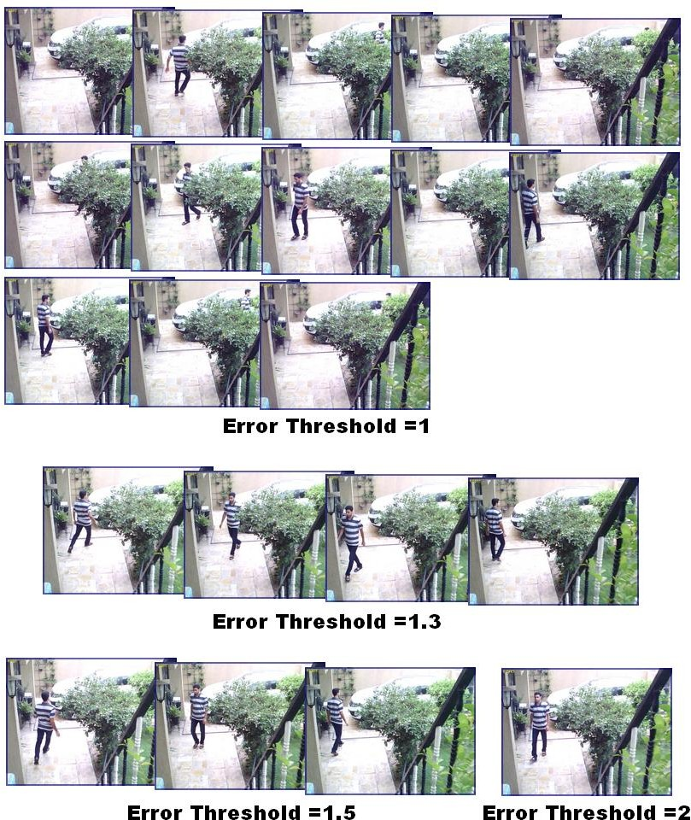

Fig.1( Testing in daylight whether the motion detected or not)

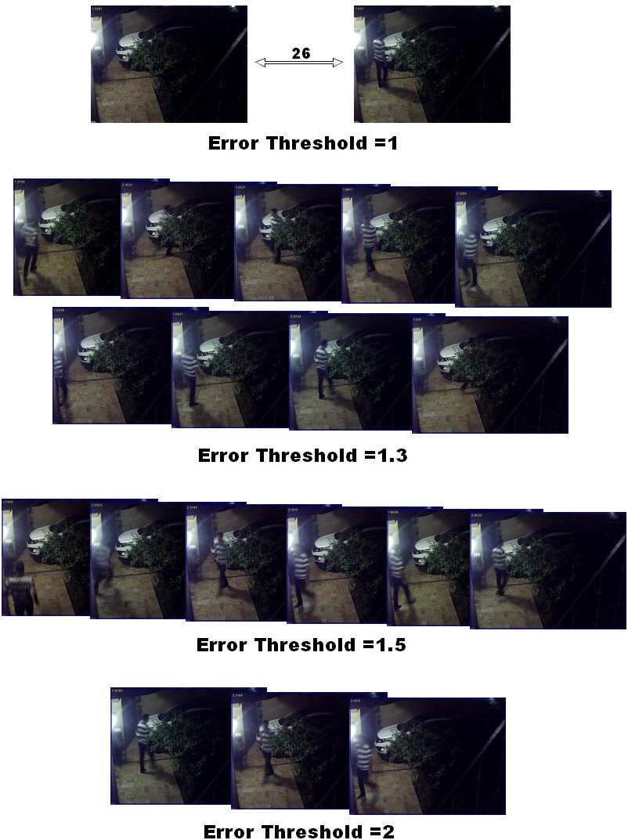

Fig. 2(Testing during the night whether the motion was detected or not)

# EXPECTED RESULTS

With the usage of smart surveillance, the user will be able to specify a window of time for keeping an eye on intruders. The systems will constantly poll data from the camera throughout the survey period. The camera will pick up movements in the event of an incursion. The user is alerted via an alert message and the taken image if the image processing detects a potential intruder.

Together with all of these capabilities, the system is projected to produce the following total results:

* An anti-theft device which may deliver a real-time alarm message Alarm.
* An easy-to-use application that allows the owner to manage when the device starts and stops.
* A reliable tool that can differentiate between a true theft and a false alert.

# 

# CONCLUSIONS

Only when the movements go beyond a pre-set threshold will the system start taking pictures? Thus, the amount of material that needs to be reviewed is reduced. Avoiding the capture of static images, which typically do not contain the item of interest, it will also help to conserve data space. It will be appropriate for both home and workplace use. If the project is successfully completed, it may be used for motion detection in smart home security systems, which would be very beneficial in auto theft detection for security purposes. Around midnight, it can also be beneficial in a bank, a museum, and a public place. In the future, we can add artificial intelligence to the system to determine the difference between true theft and just a simple object movement.

Reference

1. Raspberry Pi as Internet of Things hardware: Performances and Limitations, by M. Maksimovi, V. Vujovi, N. Davidovi, V. Miloevi, and B. Perii, Des. Issues, vol. 3, no. JUNE, p. 8, 2014.
2. H. Chaudhari, "Raspberry Pi Technology: A Review," International Journal of Innovative and Emerging Research Engineering, vol. 2, no. 3, 2015, pp. 83-87.
3. "Low cost real-time system monitoring using Raspberry Pi," 2015 Seventh International Conference on Ubiquitous and Future Networks, vol. 2015, pp. 857-859, by H.Q. Nguyen, T.T. Kim Loan, B.D. Mao, and E.N. Huh.
4. "Comparative study of motion detection algorithms for video surveillance systems," Journal of Electronic Imaging 26(2), 2017, by K. Sehairi, F. Chouireb, and J. Meunier.
5. Statistik Kriminal 2018, Badan Pusat Statistik, Indonesia, Subdirektorat Statistik Politik dan Keamanan, 2018.
6. An Advanced Internet of Things based Security Alert System for Smart Home, P. Pately, K. Patelz, S. Tyagix, N. Kumar, and M. Obaidat, IEEE, 2017.
7. "Sistem Pengontrolan Dan Keamanan Rumah Pintar (Smart House) Berbasis Android," by D. Yendri and R. E. Putri, pp. 1-6, 2018.
8. Rancang Bangun Sistem Keamanan Rumah Berbasis IoT dengan Platform Android by R. Khana and U. Usnul, Ejournal Kajian Teknik Elektro Vol. 3 No. 1, pp. 18–31, 2018..
9. Budianingsih and A. Riyanto, "Prototype Sistem Keamanan cerdas pada komplek perumahan," Jurnal Pendidikan Informatika dan Sains, 146–154, 2018.
10. The Benefits of Utilizing Raspberry Pi 3 Compared to Raspberry Pi 2 SoC Computers for Sensor System Support, J. Ivkovi and B. Radulovi, pp. 88-94, 2016.